Wodzislaw Slaski
Being a borderland town Wodzislaw Slaski is a centre of the Wodzislaw County, formed during a historical process lasting many centuries. Rich excavations, the oldest finds dated back to the stone Age, give evidence about its ancient inhabitants. The city's name derives from the Piast Duke Wladyslaw of Opole. He located the city and established the Wodzislaw monastery about 1257.
The city's origins can be traced back into the 10th and 11th century, when three Slavic settlements existed on Wodzislaw's present-day territory which eventually merged to form one town. Wodzislaw, as many other Polish settlements, was incorporated (granted city status and right) according to the so-called Magdeburg Law at some point before 1257 (the exact date remains unknown). Wodzislaw continued to be part of the Kingdom of Poland, until Silesia as a whole became a fiefdom of the Bohemian crown in 1327. At that times of Duchess Constance, the town developed fast. Wodzislaw was one of the most populated and richest towns of Upper Silesia. In 14th and 15th century the city continued to grow and developed into a regional trade centre. In the 15th century, the Hussites devastated the city. From 1526, Bohemia, including the fiefdom of Silesia, which Wodzislaw was a part of, came under the authority of the Habsburg crown. In 16th and 17th century and during the time of the Thirty Years' War, Wodzislaw has been part of the Habsburg Empire. After the end of the Thirty Years' War Wodzislaw was destroyed. At the beginning of the War of the Austrian Succession, the greatest part of Silesia, including Wodzislaw, was annexed by the Kingdom of Prussia in 1740. In 1815 the city became part of the Prussian Province of Silesia. After the end of World War I in 1918, a referendum was organized to determine the future national affiliation of Upper Silesia. Wodzislaw became part of a Polish state for the first time since 1526. The Upper Silesia plebiscite and eventual division of Upper Silesia were accompanied by three Silesian Uprisings of Polish milicians.
With the outbreak of World War II in 1939, the border city Wodzislaw returned under the rule of Germany, being in the part of Poland that was directly incorporated into the German state. The population was ethnically categorized and either "re-Germanized" or disfranchised and partially deported into the General Government as Poles.
On 22 January 1945 a death march from Nazi German's death camp Auschwitz, 56 km away, ended in Wodzislaw Slaski, where the prisoners were put on trains to other camps. When the Soviet army advanced on Poland, nine days before the Soviets arrived, the SS had marched 60,000 prisoners out of the camp. Approximately 15,000 prisoners died on the way. There is a memorial to the victims of the Holocaust from Wodzislaw in the Baron Hirsch Cemetery Staten Island, New York where the Wodzislaw landsmanshaft has a section.
In March 1945 the Soviet army arrived near Wodzisław. 80% of the town was destroyed in the war. From 26 March 1945 Wodzislaw was once more integrated into Poland.

The medieval gothic church, dedicated to the Holy Trinity
erected in 1257
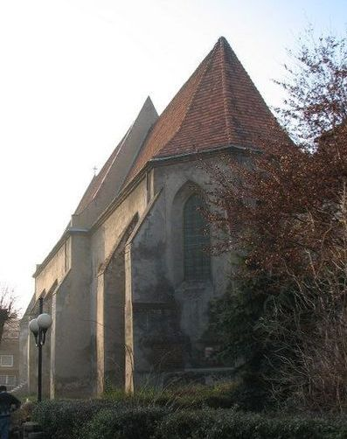

The Monastery from 17th century erected in 1257 now the local Court
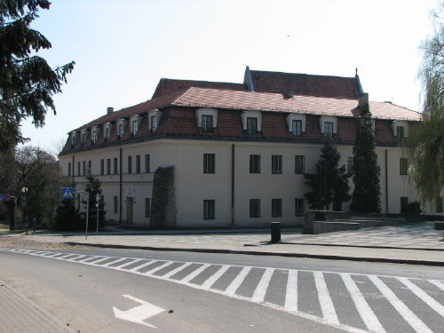

The neo-gothic church of "Assumption of St. Mary"
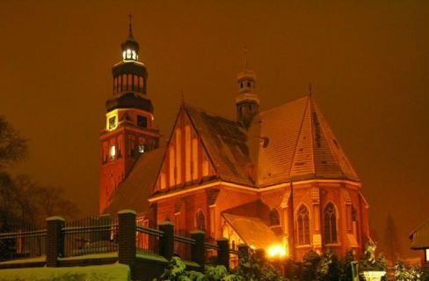

The neo-classical Wall tower

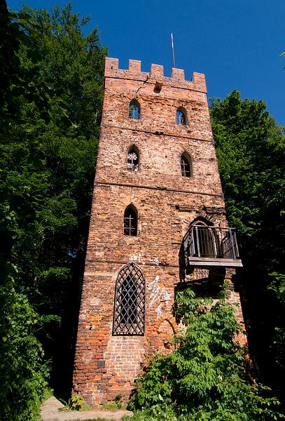

The Classicism Palace oldest in Poland from 1745. (Today Museum and town registry)
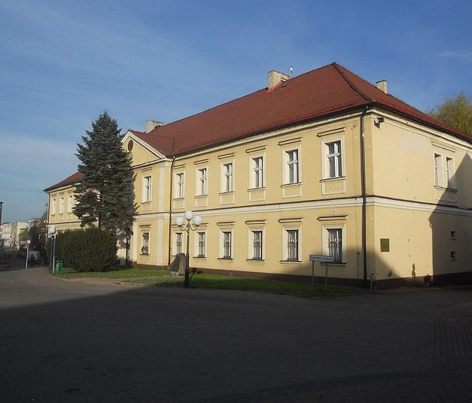

The old town square
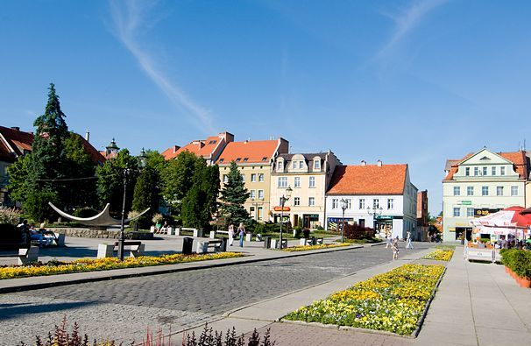

The Palace in Kokoszyce (Pałac w Kokoszycach), built in 1823
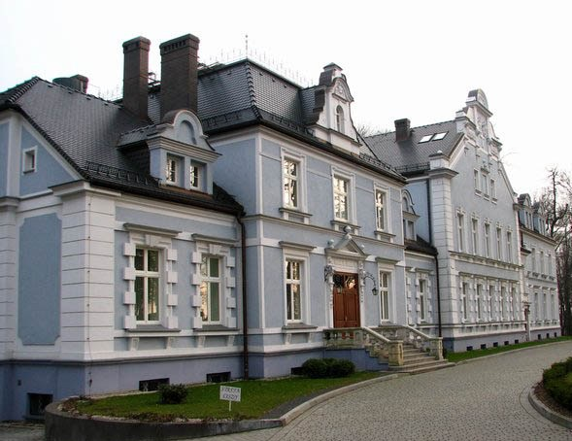

The Balaton small lake in the forest (Grodzisko)
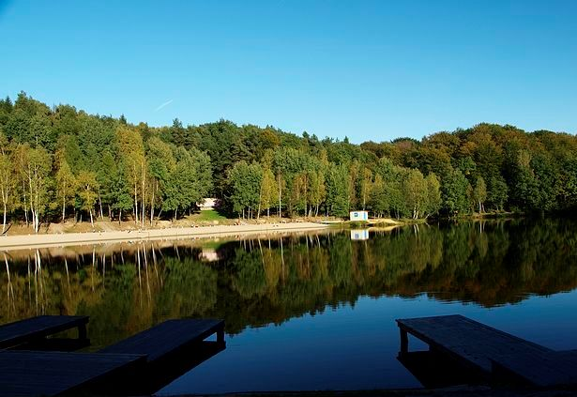

Eclectic palace in Jedlownik was built by Gottfried Hesse in 1899. The building often changed owners. One of the owners since 1860 was Edward Brauns, known for building the romantic tower in the woods in Wodzislaw. Since around 1930 the mansion was owned by the local church. Ideas to reconstruct the castle into the church or to establish a home sanatorium , were rejected. Bishop's Curia wanted to invest some charitable work in the castle, under the direction of a religious congregation . Finally, in 1933 influenced by the offer of the Sisters of Divine Providence, an agreement was concluded between the congregation and the parish . Currently a nursing home is working in the palace.

